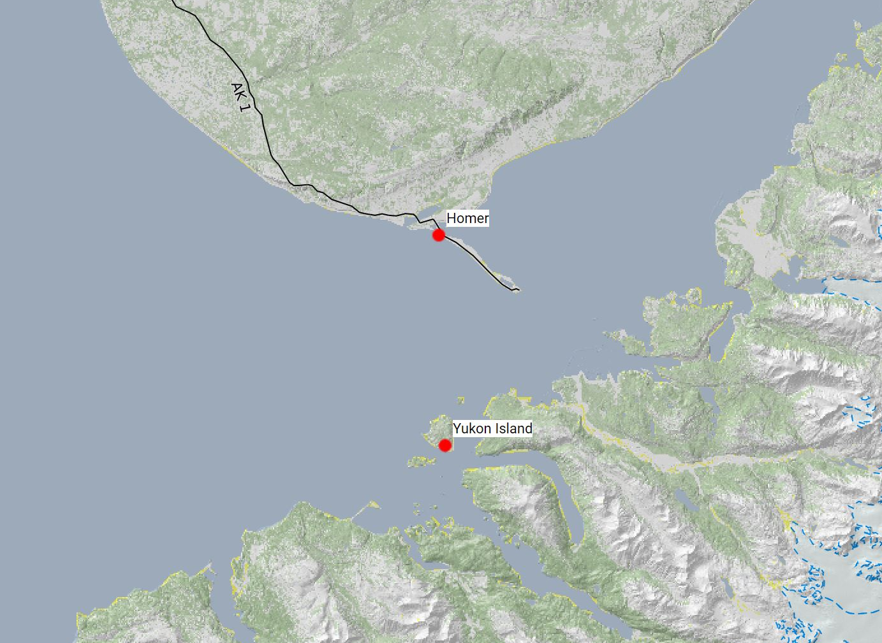
Restorative Retreat Yukon Island
August 16-18, 2019
How do we know when a movement is good? When it is pleasurable to do and pleasant to watch.
The Feldenkrais approach to movement education is not based on learning how to do something according to what someone else tells you is correct. Through the Feldenkrais Method you discover more efficient movement patterns, movement patterns more aligned with the evolutionary design of our body. You recognize the improvement in efficiency because it is more pleasurable and therefor more desirable.
This retreat is to restore us to the movement nature meant, to move with the joy and ease that is our human potential. The potential we were born with before we bent under the pressures of life and injuries. Immersion in the idyllic surrounding of Kachemak Bay, Alaska and the genuine hospitality of the Yukon Island Center, will speed this process. Class size limited to 10.
Classes will start at 9am on Friday and end at noon on Sunday. I will arrange a water taxi to depart Homer Thursday evening at 7pm, return to Homer Sunday afternoon at 3pm.
Cost including water taxi, meals, lodging and instruction is $745.
Contact Gail French at 907-344-6261, gailpfrench@gmail.com, for more information or registration
http://www.yukonisland.com/index.html
https://www.fluidmoves.net/workshops

